

Project Report

Public health web application development

By

**Inventedmost**

# Contents

1. Definition of the problem
2. Requirement Analysis
3. Design Plan
4. Architecture of Application
5. Evaluation/Testing
6. Project Tracking and monitoring activities
7. Source code
8. User Guide

## Definition of the problem

The application is titled PUBLICHEALTHAPPLICATION. This web app will allow people monitor their health, general vitals and keep track of their medical appointments.it will also allow them to update and keep record of their past medical conditions.

## Requirement Analysis

**This phase consists of:**

List of inputs to the system:

* Login details
* Basic health information
* Past medical conditions
* Search for appointments

List of outputs from the system:

* Appointment time
* Medicines and required dosages
* Important vitals
* Past medical conditions

Overview of processes involved:

* User login/signup
* Add basic information
* Add/Modify/delete relevant information
* Keep record of important information
* Sign out

Hardware and software required for implementing the project:

**Hardware**

* Intel Core i5 Processor or higher
* 8 GB RAM or above
* 120 GB Hard Disk space
* Mouse
* Keyboard

**Software**

Use software as per your requirement

* Mac OS
* Html5
* Css3
* JavaScript

Customer’s acceptance criteria for the project:

1. Create user login
2. Login to the system with created username/email and password
3. Add and modify personal details
4. Track appointments and medical data

## Design Plan

**Design specifications**

|  |  |
| --- | --- |
| **Page** | **content** |
| **Login** | **Login form containing required fields** |
| **signup** | **Signup form containing required fields** |
| **Homepage** | **Logo, clients ,username, vitals bar, appointment section and dosage section** |
| **settings** | **Edit personal information section, add medical ailments to database section** |

## Architecture of Application

#### Data Flow Diagram (DFD)

#### Flowchart

Start App

Signup/login

Yes

System Processes

No

Logout

Stop App

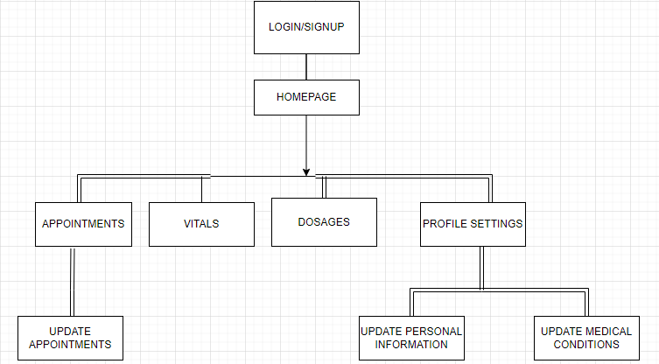

#### Database Design

**dosages**



**conditions**

|  |  |  |  |
| --- | --- | --- | --- |
| **Field Name** | **Data Type** | **Key** | **Description** |
| conditions | VARCHAR(225) | PK | Stores the name of the conditions of the patients |
| user | VARCHAR(225) | FK | Stores the name of the user this is gotten from the user table |
| Year end | INT(50) |  | Stores the year the condition was completely |
| Year start | INT(50) |  | Stores the year the condition was discovered |

**vitals**

|  |  |  |  |
| --- | --- | --- | --- |
| **Field Name** | **Data Type** | **Key** | **Description** |
| bloodpressure | INT(50) | PK | Stores the blood pressure of the user. This is self-generated. |
| user | VARCHAR(225) | FK | Stores the user’s id. This is gotten from the users table |
| glucoselevel | INT(50) | PK | Stores the glucose level. This is self generated |
| Weight | INT(50) | PK | Stores the weight. This is self generated |
| Height | INT(50) | PK | Stores the height. This is self generated |

**appointments**

|  |  |  |  |
| --- | --- | --- | --- |
| **Field Name** | **Data Type** | **Key** | **Description** |
| user | VARCHAR(225) | FK | Stores the user’s id. This is gotten from the users table |
| date | INT(50) | PK | Stores the date of the appointment |
| time | INT(50) | PK | Stores the time of the appointment |
| doctor | VARCHAR(225) |  | Stores the name of the doctor to see |
| hospital | VARCHAR(225) |  | Stores the name of the hospital to visit |

**users**

|  |  |  |  |
| --- | --- | --- | --- |
| **Field Name** | **Data Type** | **Key** | **Description** |
| username | VARCHAR(225) |  | Stores the user’s username |
| password | VARCHAR(225) |  | Stores the user’s password |
| email | VARCHAR(225) |  | Stores the user’s email |
| contact_no | VARCHAR(225) |  | Stores the user’s phone number |
| name | VARCHAR(225) |  | Stores the user’s full name |

## Evaluation/Testing

|  |  |  |
| --- | --- | --- |
| **S/N no** | **Features Tested** | **Remarks** |
| 1 | App starting | Application started successfully |
| 2 | Registration | Data sent to database |
| 3 | Login | Dummy data retrieved from database & access granted to the respective features |
| 4 | Making new appointments | Dummy data sent, retrieved and displayed successfully |
| 5 | updating personal and medical information | Dummy data sent, retrieved and displayed successfully |

## Project Tracking and monitoring activities

|  |  |  |  |  |  |
| --- | --- | --- | --- | --- | --- |
| **Date** | **Project Plan** | **Work Specification** | **Status of the Activity** | **Remarks** | **Responsibility** |
| 11/08/2022 | Started Project | Downloaded Project specification | Success | Good |  |
| 11/08/2022 | Ui design, backend code written |  | Success | Difficult with given time |  |
| 11/08/2022 | Frontend html code written |  | Success | Difficult with given time |  |
| 12/08/2022 | Testing conducted |  | Success | Good |  |
| 13/08/2022 | Submission | Submitted the project | Success | More time was required |  |

Final Checklist

|  |  |  |
| --- | --- | --- |
| **S/N No** | **Aspect Tested** | **Suggestion/Remarks** |
| 1 | Have all the modules been properly integrated and are they completely functional? | Yes |
| 2 | Does each unit meet its objective and purpose? Are all the validations happening as specified in Process Design? | Yes |
| 3 | Have all the Design and Coding standards been followed and implemented? | Yes |
| 4 | Is the GUI design consistent all over? | Yes |
| 5 | Are the codes working as per specification? | Yes |
| 6 | Does the application’s functionality resolve the client problem, and satisfy his/her needs completely? | Yes |
| 7 | Have the hardware and software been correctly chosen? | Yes |

## Source Code

Source code together with the compiled app is attached with this report

But here are some main source codes

## User Guide

**System Requirements:**

|  |  |  |
| --- | --- | --- |
| **No:** | **Items** | **Description** |
| 1 | Functional laptop | Windows 8 or higher/mac OS |
| 2 | Internet access | Must have internet connection on the device |
| 3 | 500MB RAM | laptop should have at least minimum of 500MB RAM |

**Run Application:**

**Step 1:** Open your browser

**Step 2:** type the name of the web application in your browser

**Step 3:**Click on the PHA icon

**Step 4:** login or signup and enjoy the application